**EOG based simple game interface**

**Introduction:**

An EOG (Electrooculography) based simple game interface is a type of game that uses eye movements to control the gameplay. In this type of game, the player wears a device that tracks the movements of their eyes and converts them into in-game actions.

**Dataset:**

Converted txt file to dataframe each row represent one signal

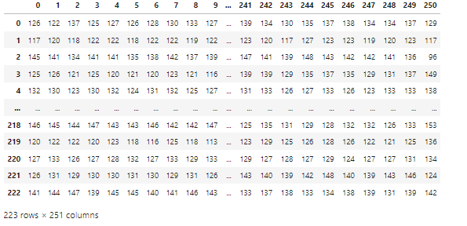

Add new column on original dataframe like (**experiment number** and **Channel** and **Label)**

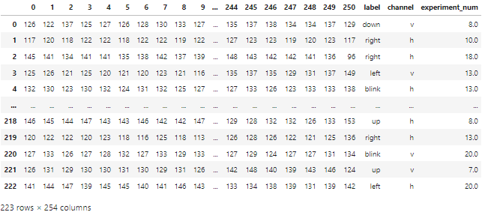

**Explore Dataset:**

* Data is balanced

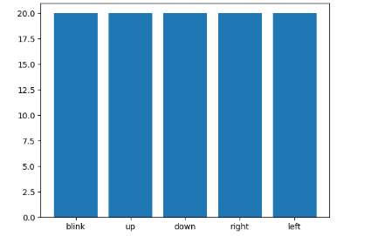

* Computed FFT of signals and plotting a sample signal of the data in frequency domain :

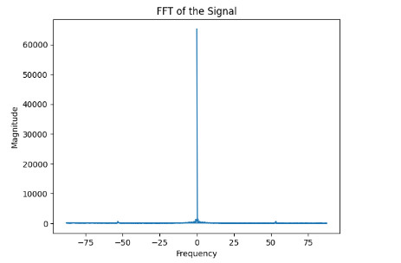

**Conclusion**: there is a **DC** component in some signals as f(0) has amplitude.

------------------------------------------------------------------------------------------------------------------------------------------

There example of signals before preprocessing

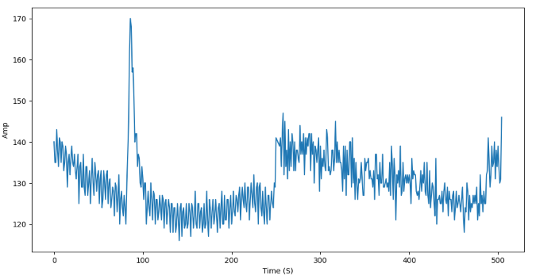

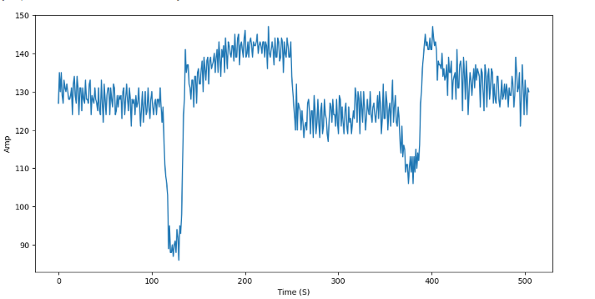

**Preprocessing:**

* **filtering using Band-pass filter**
* **resampling (down sampling) not required**
* **Removing dc component**
* **Normalization(StandardScaler)**

**Filtering using Band-paas filter:**



Some plots example after preprocessing

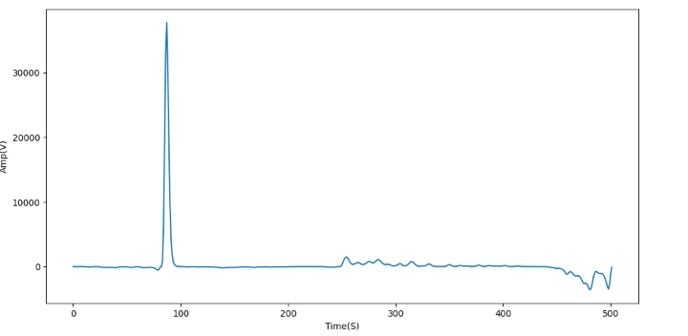 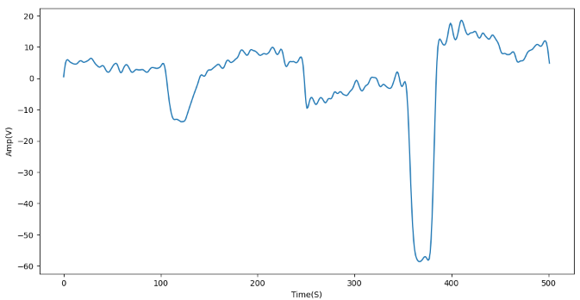

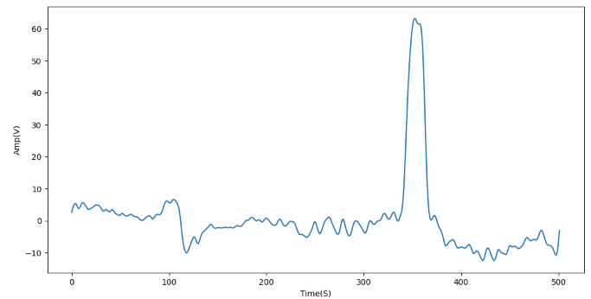

* **Remove DC**

Remove dc by subtract signal from mean

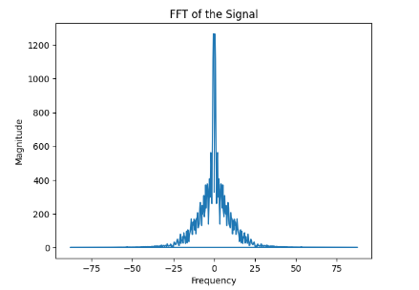

* Normalization

Normalize data using **standarscaler** (range -1 to 1)

**Feature Extraction**

* Frequency Domain

**PSD**



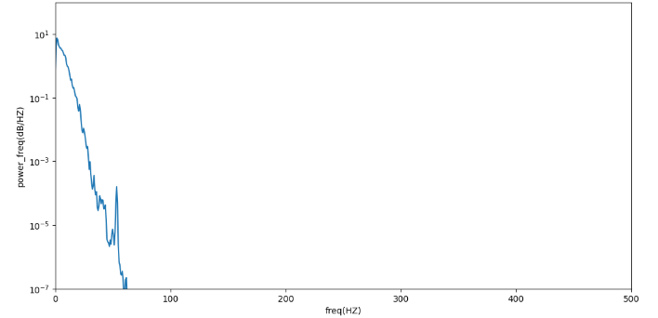

**Random Forest Classifier**

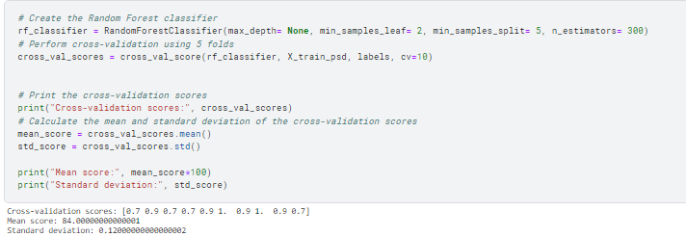

**Decision Tree Classifier**

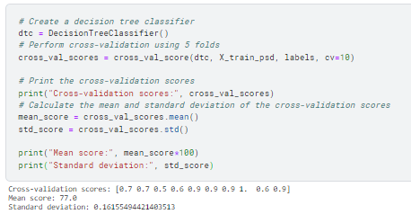

**XGBClassifier**

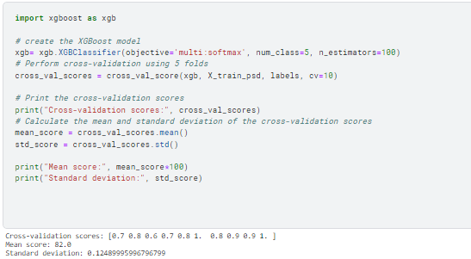

**SVC**

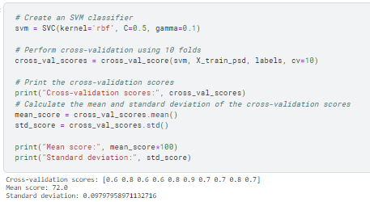

**---------------------------------------------------------------------------------------------------**

**Wavelet:**

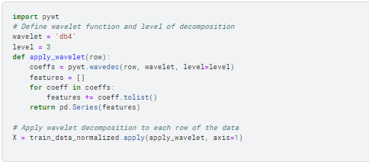

**Random Forest Classifier**

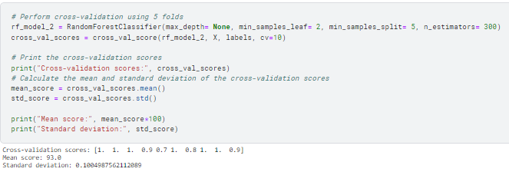

**Decision Tree Classifier**

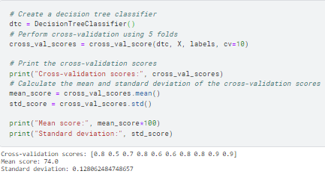

**XGBClassifier**

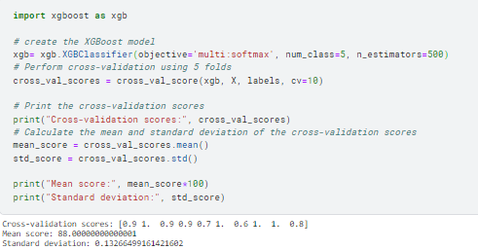

**Conclusion:**

## Wavelet feature extraction best from PSD

## the best model accuracy random forest with accuracy =100%

used grid search find best paramters of random forest

